DWC2026 – T1 Hand-off: Data, Scoring & Baseline
Oct 10, 2026 · @Khoonlyn

Status at a glance
Track 1 (Data & Baseline) is done. The clean data, the shared scoring tool, the baseline ranking and the sensitivity analysis are on branch t1-data, going to main through a Pull Request. The score to beat is 0.0036 (Case 6).
Item | Status | Where
Clean data + master table | Done | src/load_data.py → data/processed/
Shared scoring tool | Done, tested (6 tests pass) | src/metrics.py, tests/test_metrics.py
Baseline: rank the 100 existing cases | Done | src/baseline.py → outputs/baseline_ranking.csv
Sensitivity: which parameter matters most | Done | src/sensitivity.py → outputs/sensitivity_*.csv
3D grid files as parquet | Optional, not needed for the core pipeline | python -m src.load_data --grid
What every teammate does now:
- ☐ After the PR is merged: in VS Code, Command Palette → Git: Merge Branch… → origin/main (brings T1's code into your branch)
- ☐ Copy the Excel files 01 and 02 into data/raw/
- ☐ Run python -m src.load_data once (about 30 seconds)
- ☐ Read the Data rules section below before modelling

The project in one picture
The model learns from 100 simulated cases (4 parameters in, production curves out); the real field data is only used to judge and choose.
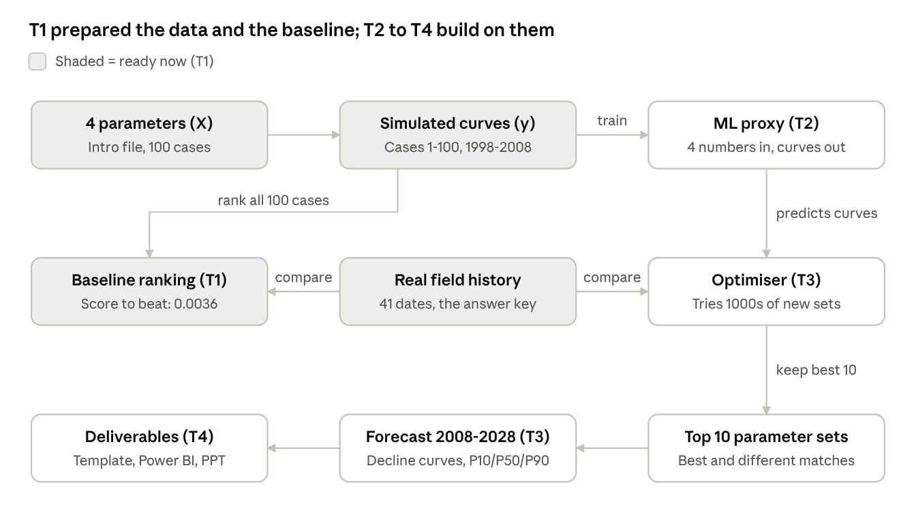
project flow · who builds what
The 3D grid files (03–08) are not part of this flow: each grid is just the 4 parameters spread over 90,000 cells, so they are only for visuals and optional extra features.

What each file does
Every setting lives in config.py, every score comes from metrics.py, and everything else builds on those two.
File | What it does, in plain words | Who uses it
src/config.py | The settings page: file paths, the case split, the 41 dates, the scoring weights. Change a setting here only, never inside your own code | Everyone
src/load_data.py | Reads the Excel files once and saves fast, clean copies (parquet). Also gives read_master(), read_history() etc. to load them in one line | Everyone
src/metrics.py | The judge. Scores how close a curve is to a target (lower = better). Same rules for everyone, so all numbers are comparable | T2, T3
tests/test_metrics.py | Checks the judge on made-up curves with known answers (a perfect match must score 0). Run python -m pytest -q after any change to metrics.py | Anyone editing metrics.py
src/baseline.py | The first leaderboard. Scores the 100 existing simulated cases against the real field and ranks them. No ML | T3, T4
src/sensitivity.py | Answers "which parameter affects production most?" with correlations and charts | T2, T3, T4
outputs/ | Result tables and charts (committed, so you get them on pull) | T4 for slides
The data files that load_data produces in data/processed/ (never committed):
File | What is inside | Main use
params.parquet | 100 cases × the 4 parameters, plus case number and split | X (inputs)
curves_long.parquet | 100 cases × 41 dates: oil, gas, water, each as cumulative and rate | Plots, rate fitting (T3)
history.parquet | The real field data on the same 41 dates | The answer key
master_table.parquet (+ .csv) | 100 rows: case, split, 4 parameters and 123 output columns | Training table (T2)
The 123 output columns are 3 curves (oil, gas, water cumulative) × 41 dates, named oil_cum_t01 (Jan 1998) to water_cum_t41 (Jan 2008).

Data rules and details
Five rules keep our results honest and comparable; breaking one makes the final numbers meaningless.
- Real history is never a training target. The model learns from the 100 simulated cases only. The real field data (RAMP_History) is only for comparing and choosing the best cases.
- Test cases (86–100) are used once. Only for the final "our proxy is X% accurate" number. Never for tuning the model or for the optimiser.
- Inputs must come from the 4 parameters only. When the optimiser tries a new parameter set, the 4 numbers are all it has. So a model input (feature) must be computable from those 4 alone.
- The optimiser stays inside the tested range (table below). Outside it the proxy is guessing.
- The data is confidential. Excel and parquet files are never committed (data/ is blocked by .gitignore). Clear notebook outputs before committing, since they can show data rows.
Parameter | Min | Max | What it means
fault_trans | 0.050 | 0.150 | How easily fluid crosses the fault
poro_mult | 0.80 | 1.49 | Scales the pore space (how much fluid the rock holds)
perm_mult | 0.52 | 9.78 | Scales how easily fluid flows through the rock (lower layers only)
aquifer_pv | 54 | 200 | Size of the water body pushing on the reservoir
How the data was prepared:
- One row per case, on 41 dates. The simulator saved values on its own irregular dates, so each case's column was mostly blank. We kept only the 41 quarterly dates where the real field was measured (1 Jan 1998 to 1 Jan 2008). Every case has an exact value on those dates, so nothing is estimated.
- Case split: train = cases 1–70, validation = 71–85, test = 86–100 (fixed by the organisers).
- Rates are calculated from the cumulative totals. We found the simulator and the real data report rates three months apart: the real rate on 1 Oct 1998 means "Oct–Dec", the simulator's means "Jul–Sep". So we compute every rate the same way: rate = (this quarter's total − last quarter's total) ÷ days in the quarter. Always use our oil_rate, gas_rate, water_rate columns, never the raw rate sheets. The original real rates are kept as *_reported in history.parquet.
- No data exists after Jan 2008, for any case or for the real field. The 2008–2028 forecast is a true prediction (T3).
- Grid files: the value −999.25 means an empty cell (no rock) and is turned into a blank. About 42,500 of the 90,365 cells are real rock.

How the score works
One number says how close a curve is to its target: 0 is a perfect match, and 0.01 means the curve is off by about 1% of the field's maximum on average.
metrics.py computes it in four steps, the rules the team agreed on 10 Oct:
- Skip the first 3 quarters of 1998. Nothing is produced yet, so every case is a perfect 0 there; counting them would flatter everyone. Scoring starts on 1 Oct 1998 (38 of the 41 dates).
- Measure the gap at each date between the curve and the target, then take the typical gap (RMSE: square the gaps, average them, take the square root).
- Turn the gap into a share of the real field's maximum (NRMSE). Oil reaches about 38 million barrels while gas and water reach 13–14 million, so without this step oil would dominate the score.
- Combine oil, gas and water with ⅓ weight each into one score.
\text{score} = \tfrac{1}{3}\,\frac{\text{RMSE}_{oil}}{\max \text{oil}_{real}} + \tfrac{1}{3}\,\frac{\text{RMSE}_{gas}}{\max \text{gas}_{real}} + \tfrac{1}{3}\,\frac{\text{RMSE}_{water}}{\max \text{water}_{real}}
Tiny example: if a curve is off by 10 at every date and the real maximum is 100, that stream's NRMSE is 10 ÷ 100 = 0.10. If all three streams are off the same way, the score is 0.10.
The main score uses cumulative curves (smooth, and what the final template asks for). Rates are scored as a second opinion: when both rankings agree, the ranking is trustworthy.
The tool has two uses:
Function | Compares | Used by
score_vs_history() | Any curves vs the real field | T1 baseline, T3 optimiser
proxy_report() | Proxy predictions vs the simulator's own curves (validation / test cases). Gives NRMSE, R² and the % error on the 2008 total | T2
Never write your own scoring code; import these so every number in the slides is comparable.

Findings and what they mean for each track
The history pins down porosity (multiplier about 1.36) but not the other three parameters, and no existing case gets the last two years right.
Baseline top 10 (from outputs/baseline_ranking.csv; score: lower = better):
Rank | Case | Split | Porosity | Permeability | Aquifer | Fault | Score
1 | 6 | train | 1.358 | 2.47 | 120 | 0.058 | 0.0036
2 | 97 | test | 1.346 | 5.41 | 154 | 0.052 | 0.0038
3 | 76 | validation | 1.383 | 1.64 | 182 | 0.108 | 0.0039
4 | 11 | train | 1.354 | 7.34 | 188 | 0.125 | 0.0039
5 | 40 | train | 1.354 | 4.96 | 133 | 0.144 | 0.0040
6 | 73 | validation | 1.354 | 1.47 | 93 | 0.083 | 0.0041
7 | 50 | train | 1.357 | 7.46 | 171 | 0.100 | 0.0045
8 | 20 | train | 1.361 | 5.08 | 123 | 0.062 | 0.0050
9 | 26 | train | 1.346 | 1.94 | 54 | 0.098 | 0.0059
10 | 4 | train | 1.364 | 8.60 | 158 | 0.146 | 0.0066

Finding | What it means | For
The best existing case (Case 6) scores 0.0036: its curves are off by about 0.4% of the field maximum | This is RMSE_baseline, the number to beat. Headline later: "ML improved the match by X%" | T3, T4
Water is the hardest stream: its error is 3–4 times larger than oil and gas in every top case | Most room to improve is in water | T3
Porosity sits at 1.35–1.38 in all top 10 cases, and drives every key output (correlation 0.93–1.00) | More pore space = more oil, later water arrival, longer plateau. The history decides porosity | T2, T3
Permeability (1.5–8.6), aquifer (54–188) and fault (0.05–0.15) vary widely in the top 10; correlation with outputs only ±0.15 | The past cannot tell their values (non-uniqueness). Different reservoirs fit equally well, so forecasts after 2008 will spread out: that spread is our P10/P50/P90 range | T3, T4
All top 10 make the same mistake in 2007–08: too much oil and gas (up to +1.4%), too little water (up to −4.5%) | No existing case captures the field's late trend. Used as-is, they would give an optimistic forecast (too much oil, too little water) | T3, T4
Rate-based and cumulative rankings agree on 8 of the top 10 | The ranking is trustworthy | Everyone
Real field: water arrives 2.08 years after start; the oil plateau ends after 3.37 years | Useful checks for any matched or forecast curve | T3
Practical tips:
- T2 (proxy): porosity will be learned easily; check that the model also captures the small effects of the other three. A Gaussian Process, or using log(perm_mult) as input, may help. Report accuracy with proxy_report() on validation, and on test once at the end.
- T3 (optimise + forecast): expect the optimiser to agree on porosity near 1.36 and spread on the rest. Success = the error lines in baseline_top10_closeup.png hugging zero in 2006–08, especially water. Pick 10 different parameter sets, not 10 copies of one.
- T4 (story): good slide visuals are baseline_top10.png (fan vs real data), baseline_top10_closeup.png (the shared late error) and sensitivity_tornado.png (porosity dominates). Say "porosity dominates the 1998–2008 history", not "porosity is the only thing that matters": the others may matter more after 2008.
- Weights: gas is almost exactly 0.363 × oil in this data, so equal weights count oil twice. Oil ½ + water ½ (gas reported, not weighted) is a reasonable alternative; it is one line in config.py.

Getting started and next steps
Only one command is required on your laptop; the README in the repo has the full guide and a troubleshooting table.
- Python 3.12, a .venv environment with requirements.txt installed (VS Code: Python: Create Environment).
- Excel files 01 and 02 in data/raw/ (only the 2-digit prefix of the name matters).
- In the terminal, from the repo root: python -m src.load_data. Expect master_table (100, 129) and no warnings.
- Optional, to re-create T1's results: python -m pytest -q (expect 6 passed), python -m src.baseline, python -m src.sensitivity.
Loading the data in your own code:
from src import config as C
from src.load_data import read_master, read_history, y_columns
from src.metrics import score_vs_history, proxy_report, split_y
master = read_master()
X = master[C.PARAM_COLS] # 4 inputs
y = master[y_columns()] # 123 outputs
train = master[master.split == "train"]
Next steps by track:
Track | Next step | Uses from T1
T2 Proxy | Train on cases 1–70, tune with 5-fold cross-validation + validation (71–85), test once | master_table, proxy_report()
T3 History match | Search thousands of new parameter sets through the proxy; keep the 10 best and different ones; beat 0.0036 | score_vs_history(), parameter ranges
T3 Forecast | Fit decline curves to the late rates of the top 10; project to 2028; fill the template | curves_long rates, history
T4 Story | Background slides, dashboard layout, T1 charts | outputs/figures/
Open questions for the team:
- Keep equal weights (⅓ each), or switch to oil ½ + water ½?
- The proxy only covers 1998–2008 (no simulated data after). Agree early how T3 extends the top 10 to 2028 (decline curves are the plan).

